Round1
- What is abstraction?.
- How to add user defined objects in HashSet?

- How equals and hashCode works? Sample Code
- How to improve performance for read and write in hashSet?
  - If all value lands in same bucket read will be good. Same is true for write also.
- Class has 2 Synchronized methods. Create a object, create 2 thread for object. Is it possible for thread1 to method1 and thread2 to access method2 at the same time.
  - Ans: No. If 2 objects are created then possible.
  - Now if 1 method is changed to static. What will happen? Then T1 can access M1 and T2 can access M2.

- Hibernate how to represent the Collection Ex: Device(Computer System) has many cards. Cards(LAN Cards) has many ports.
  - Using annotation manyToOne in Device with Join Column.
- If I update or delete a device. How to reflect the same in Cards.
  - Using the property cascade: saveOrUpdate and deleteOrphan.

- For the view I want to send only the Device object and nothing else?
  - Use Transfer object. Copy Device in TransferObject and send to view.
- AbstractFactory is like factory of factory. First I will get the factoryType by passing argument and then I will pass another argument to get the object from the factory.
- Explain Singleton Pattern?

Round2

- What is HeapDump?
- How will you analyse the HeapDump? How will analyse the live object? Sample framework used for the purpose?.
- Write a sample code for runtime polymorphism?
- What are the difference between Restful and SOAP
  - REST is lightweight. Simple. It is not a protocol. REST is a concept that does not tie with any protocols.
  - SOAP is a XML based messaging protocol.
- What is the maximum number of thread that a servlet container can create for a request.
  - It is configured tomcat configuration server.xml and not present in web.xml
- Have 2 input array a1=”1 to 26” and a2=”a-z”… Create 2 threads T1 and T2… T1 should access a1 & T2 should access a2. Output should be 1a2b3c4d
  - Go for wait and notify. T1 access a1 prints a value, goes to wait… and call T2. T2 prints a value, calls notify… for loop it for 26 times.
  - Create 2 Threads, 2 Blocking Queues,
T1 should read from a1 and should place data on q1.
T1 should read data from q2 and should print
T2 should read from a2 and should place data on q2.
T2 should read data from q1 and should print.
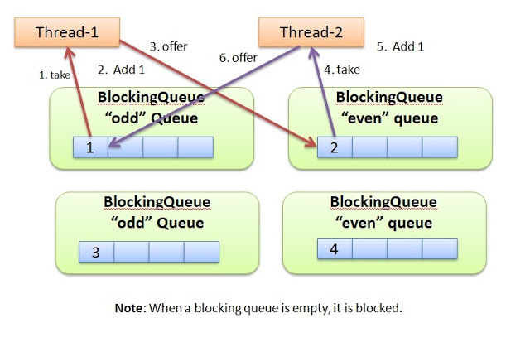
- What is the difference between JMS and WebService
  - JMS provides data persistence capability
  - Web Service is always synchronized whereas JMS supports both sync and async model.

